**SEQUENTIAL DIAGRAM**

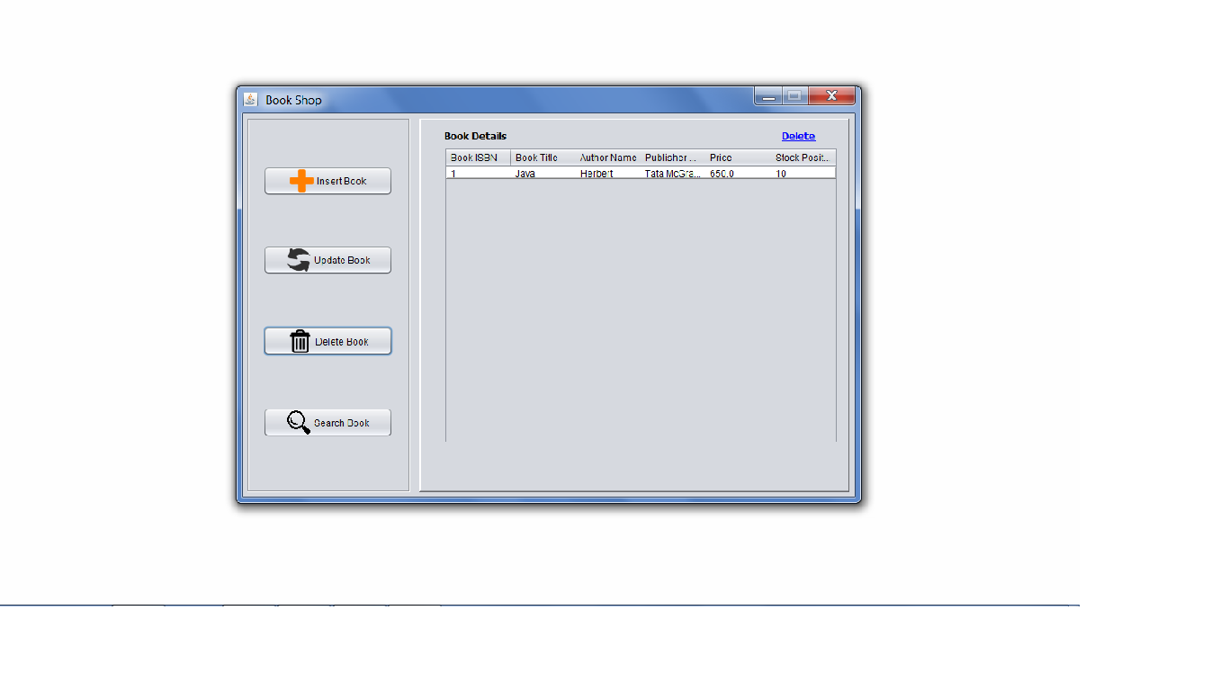

Delete Window

The above interface is DELETE module interface. After clicking on **DELETE BOOK** button, this interface will be appeared.

For deleting a row, select that row and press **Delete** button on top-right corner :

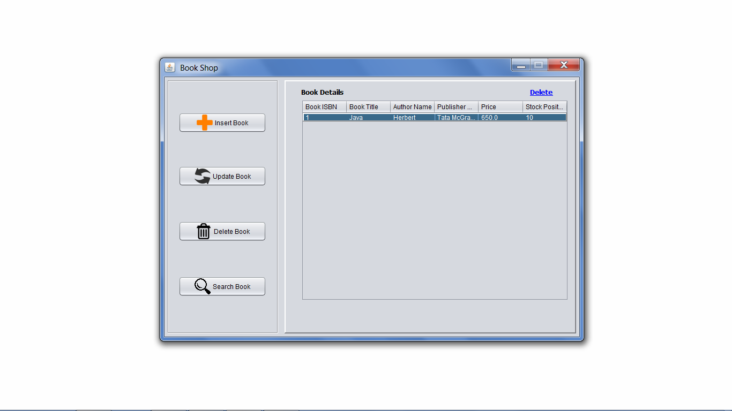

After clicking the **Delete** button, the row will be deleted :

